

User’s manual

Elevator
(+ hopper)

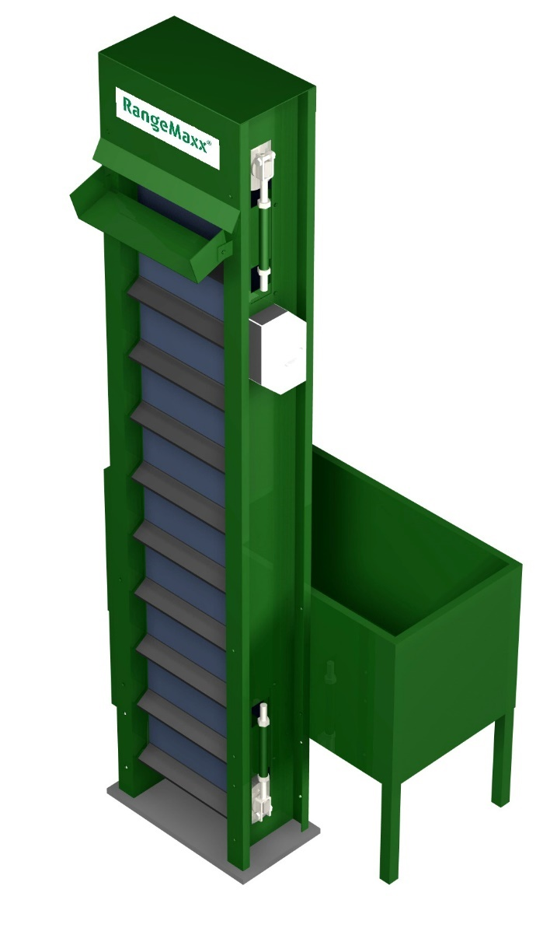

Contents

1. Contents 1
2. Foreword 2
3. Warranty and liability 3
4. Safety 4
4.1 CE marking 4
4.2 Safety instructions 4
4.3 Explanation of pictograms 5
4.4 Intended use and operation 6
5. Overview 7
6. Installation instructions 8
7. How to use the elevator? 9
8. Maintenance 9
8.1 Cleaning in general 9
8.2 Oiling 9
8.3 Adjusting the tension in the conveyor belt 10
9. Disorders 10
9.1 Trouble shooting 10
10. Technical data 11

Foreword
You are in possession of a Range Maxx® golf ball elevator. We thank you very much for your trust in our product. With the design and the fabrication of the machine we have given our greatest attention to the quality and the durability in combination with affability for usage and maintenance. When you follow the instructions in this manual the Range Maxx® will serve you without for years.

This manual has been written for Range Maxx® Ball Elevators, types:
- Medium
- Large
Complete with a Range Maxx® Storage Hopper:
- Small
- Standard
- X-Large

The machine has been intended exclusively for vertical transportation of golf balls. By change of use the CE marking is no longer valid.

Warranty and liability
Range King golf course equipment gives you a warranty on the new machine for the period of 12 months on the mechanism and the electrical parts.

In this warranty are not included failures, which occur by means of:
- not observance of the operation- and warranty instructions or other than the normal usage;
- normal wastage;
- alteration or reparation by or on behalf of the buyer executed by a third party, without a written permission of Range King;
- placing assemblies which are not delivered or placed by Range King;
- damage to the machine caused during the transport if this damage is not reported instantly after receipt of the machine. First examine the machine completely and report damage.

Always mention in all correspondence the serial number. This number you can find under the operation switch at the side of the elevator.

If anything is not clear to you with reference to this manual please contact:

Range King golf course equipment
Dirk Storklaan 23-24
NL-2132 PX Hoofddorp
The Netherlands

www.RangeKing.eu

T +31 23 562 3855
info@rangeking.eu

Safety
- Connect the machine to an earthen socket.
- Make sure the power cables don’t come in contact with water.
- Several parts in the machine are under dangerous voltage; when opening the machine always disconnect plug from socket to prevent electrocution.
- Prevent severe injuries; do not approach moving parts and do not put your hands in a machine in operation.
- Incompetent use can possible lead till material or physical damage.


Caution! Moving parts: do not place hands in machine when in operation.


Always disconnect power plug from socket when inspecting or repairing
the machine.

Read this manual thoroughly.

CE marking
The Range Maxx® Ball Elevator complies with the European guidelines of the machinery and the EMC directives. See declaration of conformity for details.

Safety instructions
In case of material damage or personal injuries, caused by incompetent usage or not observing this manual and safety instructions, we do not accept any responsibility.

The machine was in perfect condition when transported from the production factory. To maintain this state and guarantee a save operation, the intended use, the safety instructions and safety warnings ought to be observed.

Due to safety measures and admission-demands (CE) it’s not permitted to make alterations to the machine or it’s components with one’s own hands without permission of Range King®.

Please refer to your supplier or a skilled craftsman when you have questions regarding to the working method, safety or connections of the dispenser.

Do not leave the packaging material unguarded; these materials can be hazardous for young children.

The elevator can only be used under a roof in a sheltered place.

When it’s assumed that a save operation is no longer guaranteed, the machine must be put out of order. A save operation is not possible when:
- the machine shows clear damages
- the machine does not function
- after long storage under unfavorable conditions

Explanation of pictograms

Warnings are frequently used in this manual. These warnings are indicated with pictograms, with the following meanings:

Caution! High voltage!

 Warning! (In general)

Danger! Be aware, do not approach moving parts!

Tip or complementary information.

Intended use and operation
The Range Maxx® Ball Elevators are exclusively intended for transporting golf balls in a vertical direction. The golf balls can be loaded by hand in the Hopper or by a Range Maxx® Ball Washer.

The balls are scooped out the Hopper by the conveyor belt. The upper cylinder contains an electric motor that powers the belt. When the balls reach the top of the lift, they roll off the cylinder onto the ball-outlet. Via the ball-outlet they drop in a Range Maxx® Golf Ball Dispenser a Range Maxx® Ball washer or a Storage Unit.

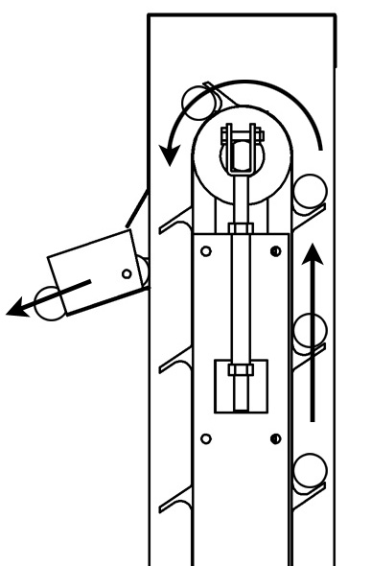
Image 4.1, functioning

Overview
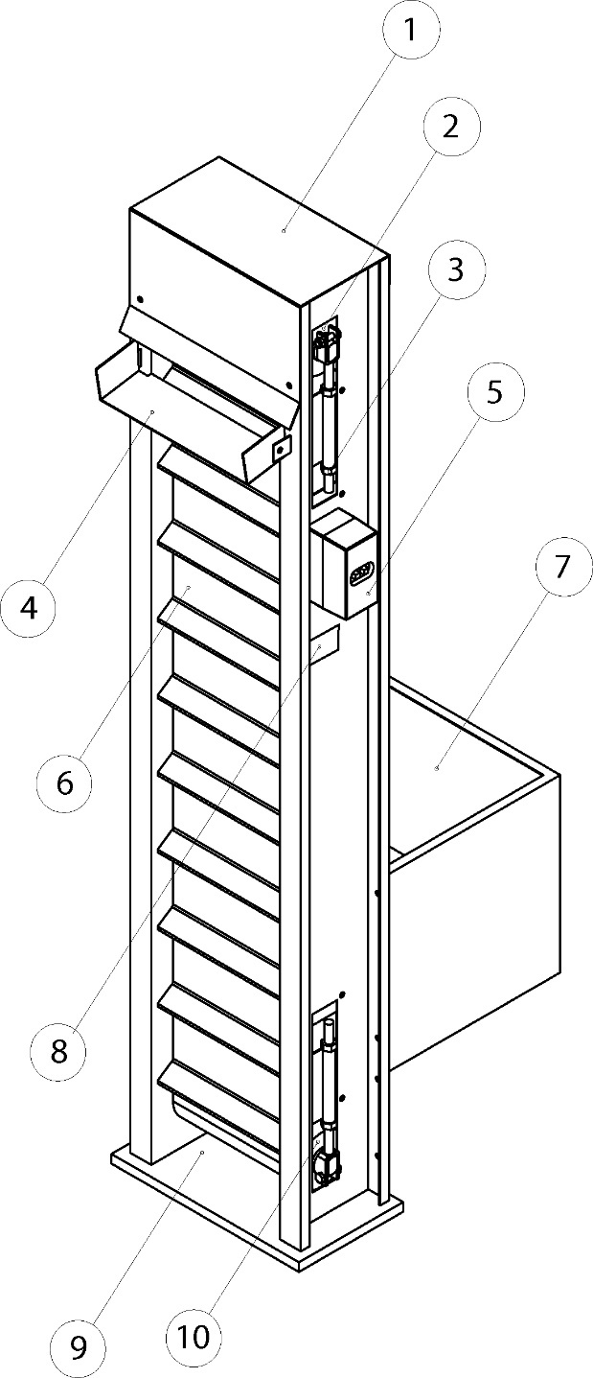
Image 5.1, overview Elevator with Basic Hopper

1. Top lid | 6. Conveyor belt
2. Cylinder motor | 7. Hopper
3. Adjustment bolt (4x) | 8. Identification tag
4. Ball outlet | 9. Rubber foundation
5. Operation switch | 10. Turning cylinder

Installation instructions
In this installation guide a standard configuration with a Range Maxx® Ball Dispenser (+ version) with an Elevator is used.

Install the elevator by following these instructions:
- Place the elevator on the rubber foundation (9) at the backside of the dispenser. Make sure the machines are water-leveled; if the machines tilt they will not operate properly.
- Bolt the elevator on four points to the dispenser
- Put the two triangle shaped plates in place on the back of the dispenser
- Take the Hopper and connect it to the elevator
- Plug the line plug into an earthen plug-socket
- The elevator is now ready to use.

The machine may only be connected to an earthen socket!

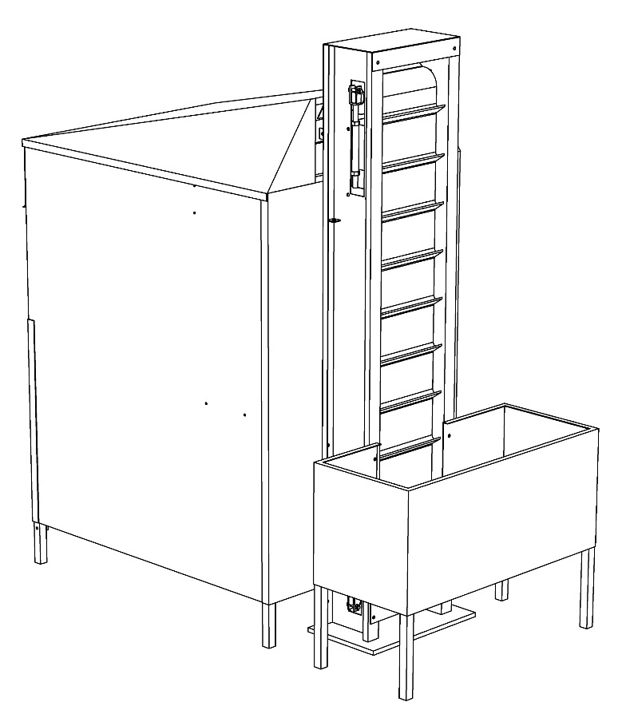
Image 6.1, configuration with Dispenser+ and Elevator

How to use the elevator?
- Start
To start the conveyor belt use the black (START) button on the side of the elevator.

- Stop
On any given time the elevator can be stopped. Press the red (STOP) button; the conveyor will stop immediately.

Maintenance
Remove the plug from its socket before you start maintenance. Various
parts are under voltage when the plug is in.

Cleaning in general

The outside of the machine can be cleaned with a moist cloth and a not-aggressive cleaner. Do not use aggressive solvents because they can damage the lacquer. Touch up little lacquer damages in time, then further damage will be limited.

The electrical parts like motor (2) and stop switch (5) may not connect with water.

When filling the machine with balls, prevent any other objects such as twigs, stones, sand, leaves or other things from being also put into the hopper.

Clean the elevator regularly; remove leaves, grass, sand, etc. from the scoops.

Oiling

The bearings in the motor and de turning cylinder do not need maintenance; no extra lubrication is necessary.

Adjusting the tension in the conveyor belt
When the tension is too high, the motor uses unnecessary power to spin the belt and the bearings are wearing down to quick. On the other hand, a weak adjustment causes the belt to slip.
The elevator leaves the factory in perfect configuration; the conveyor belt doesn’t need adjusting. But after a while it might be useful to check the tension of the belt to maintain the optimal operation. Follow these instructions:

- Remove the plug from it’s socket
- Screw/unscrew the adjustment bolts on both sides of the elevator until the proper tension is reached
- Be aware that the cylinders are exactly parallel and perpendicular to the sides. This prevents running up of the belt to the sides.

Disorders
Remove the plug from its socket before you start maintenance. Various
parts are under voltage when the plug is in.

Always consult the “trouble shooting guide” before calling a technician for help. Often it is possible to solve the problems yourself or if you cannot solve it yourself, a technician might give you a good advice.

Trouble shooting
Symptom | Possible course | Solution
The conveyor belt isn’t running | The power is cut-off | Check the power-cord and plug
 | The tension of the belt is to strong or to weak | Adjust the belt’s tensions with the adjustment bolts
 | The belt is blocked | Remove objects from the conveyor belt
The conveyor belt runs up to a side | One, or two cylinders are not perpendicular to the sides | Adjust the belt’s tensions with the adjustment bolts

The elevator is equipped with a safety-switch, which will turn off the motor in case of over overload.

Technical data
Range Maxx® elevators |  |  | Range Maxx® storage hoppers
 | Medium | Large | Basic hopper | Standard hopper | X-large hopper
Power | 230 VAC / 110 Watt | 230 VAC / 110 Watt | - | - | -
Weight | 80 kg | 85 kg | 5 kg | 8 kg | 22 kg
Dimensions | 41 x 21 x 196 cm | 41 x 21 x 230 cm | 41 x 41 x 41 cm | 92 x 41 x 41 cm | 121 x 92 x 570 cm
Capacity | 30.000 ball per hour | 30.000 balls per hour | 800 balls | 1.600 balls | 6.000 balls

EC declaration of conformity

Manufacturer: Range King
Address: Dirk Storklaan 23-24
2132 PX Hoofddorp
The Netherlands

Declares, under own responsibility, that the product:

Range Maxx® Elevator

Model: ……………………………………......

Date of man.: ……………………………………......

Serial no.: ……………………………………......

about which this declaration concerns, is in conformity with the standards

- EN 292-1, EN 292-2, EN 292-2A, EN 1050, EN 1599

and in conformity is with the essential health and safety requirements of the

- directive for machinery 98/392/EG
- directive for EMC 89/336/EEC

……………………………………......
Hoofddorp

..…………………………………......

