

User’s manual

Golf ball dispenser with integrated light-duty washing installation
Medium(+), (X-)Large(+), Twin Medium, Twin (X-)Large

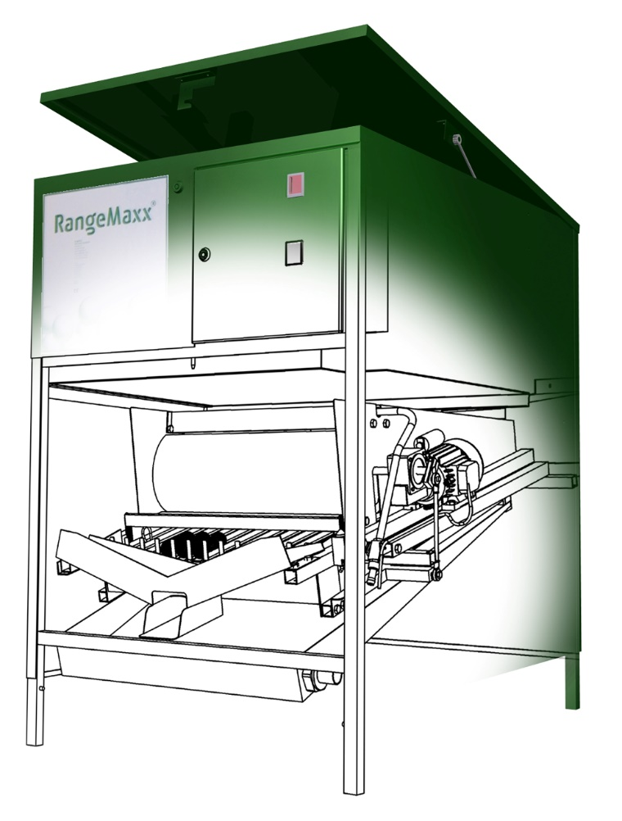
06-04-2020 V05
Contents
1. Introduction 1
2. Warranty and liability 2
3. Safety
3.1 CE marking 3
3.2 Safety instructions
3.3 Remaining dangers
3.4 Intended use and operation 5
4. Survey
5. Installation 7
5.1 Connecting water and electricity 9
6. Maintenance
6.1 Cleaning in general 10
6.2 Oiling
6.3 Cleaning the coin mechanism 11
6.4 Draining water with frost 11
7. Disorders
7.1 In general 12
7.1.1 Ball dispensing
7.1.2 Insufficient water supply 12
7.2 Trouble shooting guide 13
8. Wiring schedule 14
9. Payment systems 17
9.1 Coin accepting mechanism 17
10. Technical specifications 18
11. Repair manual 19
11.1 Removing the dispensing mechanism 20
11.2 Removing the brush 21
11.3 Adjusting the brush
11.3.1 Transport and moving
11.4 Replacing magnetic card reader

© 2005 copyright Range King; all rights reserved. Nothing from this edition shall be copied or published without prior written permission of Range King.

Introduction
You have bought a Range Maxx® golf ball dispenser. We thank you for your confidence in our product. During the design and production of this machine we have given great attention to quality and durability and combined this with a high level of users and maintenance kindness. If you follow the instructions as described in this manual, the Range Maxx® dispenser will serve you trouble-free for several years.

This user’s manual has been written for the Range Maxx® golf ball dispensers:
- Medium
- Medium +
- Large
- Large +
- X-large
- X-large +
- Twin Medium
- Twin Large
- Twin X-large
- Twin XX-large

These machines have exclusively been designed for dispensing of golf balls. Any change of the use purpose will end the validity of the CE marking.

Warranty and liability
Range King® gives a warranty for a new machine over a period of 12 months on mechanical and electrical parts.
No guarantee can be claimed in any case for failures occurring in or caused partially or completely by:
- not following the observance of the control- and maintenance prescriptions or following the normal use of the product;
- normal wearing out;
- changes or repair by or on behalf of the buyer performed by third parties, without written approval of Range King®;
- connecting or mounting assemblies that have not been supplied or approved by Range King®;
- damage to the machine caused during transportation, in case this is not reported immediately after receipt of the machine. Therefore, always check deliveries on transport damage.

Please always mention the information written on the identification tag in your correspondence. This tag is located at the right side inside the coin insert box.

Should there be any obscurity with reference to this user’s manual, please contact with:

Range King golf course equipment
Dirk Storklaan 23-24
2132 PX Hoofddorp
The Netherlands

www.RangeKing.eu

T +31 23 562 3855
info@rangeking.eu

Safety
- Connect the machine to an earthen socket.
- Install the power cable in a way that it can not lay in water.
- Some parts of the machine are powered with high voltages; when opening the front lid, pull the plug out of the socket in order to prevent from electrocution and jamming between mechanical parts.
- Prevent from serious injuries by not approaching moving parts; do not put your hands inside an operating machine.
- Inexpert assembly and/or use can cause material or physical damage.


Beware of getting jammed between moving parts! Never stick your hands inside a
moving machine!


Always pull the plug out of the socket during performance of maintenance
or inspection.

Read this user’s manual thoroughly; anyone committing maintenance or repair to
this machine must take notice of the contents of this document.

CE marking
The Range Maxx® ball dispenser complies with the obligated safety requirements of the machinery and the EMC directives, as lined up by the European Community. Further, relevant harmonized standards have been applied. For details, see the declaration of conformity.

Safety instructions
In case of material damage or personal accident, caused by injudicious use or not following the user’s manual and safety-indications, we do not accept any responsibility. In such case every right to warrantee claims also expires.

The machine has left the manufacturing plant in safety wise perfect shape. To keep it in this shape and to use it without risks, you will have to take the directions of ‘correct use’, the safety rules and the warnings serious.

For safety- and permissions reasons it isn’t allowed to rebuild or to change exponents from the machine.

Please ask your supplier or another recognized expert when you have questions about the method, safety or connections of the machine.

You should not let the packing lie around. Plastics, foils and others are dangerous toys for children.

The machine should only be placed under a roof, at a sheltered place.

When can be assumed that safe use is not possible anymore, the machine has to be turned off and intentional usage must be prevented. Assumed can be that safe use of the machine is not possible anymore, in case:
- the machine shows real and explicit damage;
- the machine doesn’t function anymore;
- after long storage under bad conditions;
- after heavy transport conditions.

Remaining dangers
Although the machine meets the fundamental safety rules of the applied directives, there will always be dangers that can not be prevented. You will be warned for these dangers by stickers and in this manual by pictograms. The meaning of the pictograms:

Danger! Watch out! Parts under voltage!

 Danger! Warning!

Danger! Watch out for jamming of the rotating parts!

Tips or extra information.

Intended use and operation
The Range Maxx® ball dispensers are exclusively meant for storage and dispensing of golf balls. The dispenser can be used alone, or it can be a part of the Range Maxx® ball handling system. The golf balls can be put in the storage place by hand, but with use of the Range Maxx® ball handling system the dispenser will be filled by the Range Maxx® elevator or Range Maxx® turbo blowing system.

The unique ball dispensing mechanism works as followed: De balls roll over the ball grate in the direction of the brush, the brush spins against the balls, by which it cleans the balls slightly. The brush is also for the dosage of the balls. The balls roll above the ball lift. When the user activates the system by paying, the lift will rise and lift the balls (adjustable quantity of even numbers between 12 and 24 per cycle) over the cams. The balls will roll through the outlet in the bucket (or something like that) of the user. The machine will do this more times dependent on the adjustment of the control module.

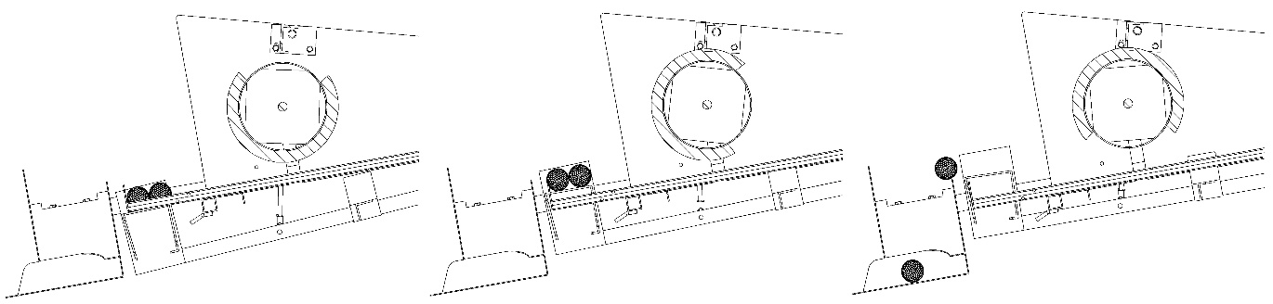
Image 3.4.1, working

Survey
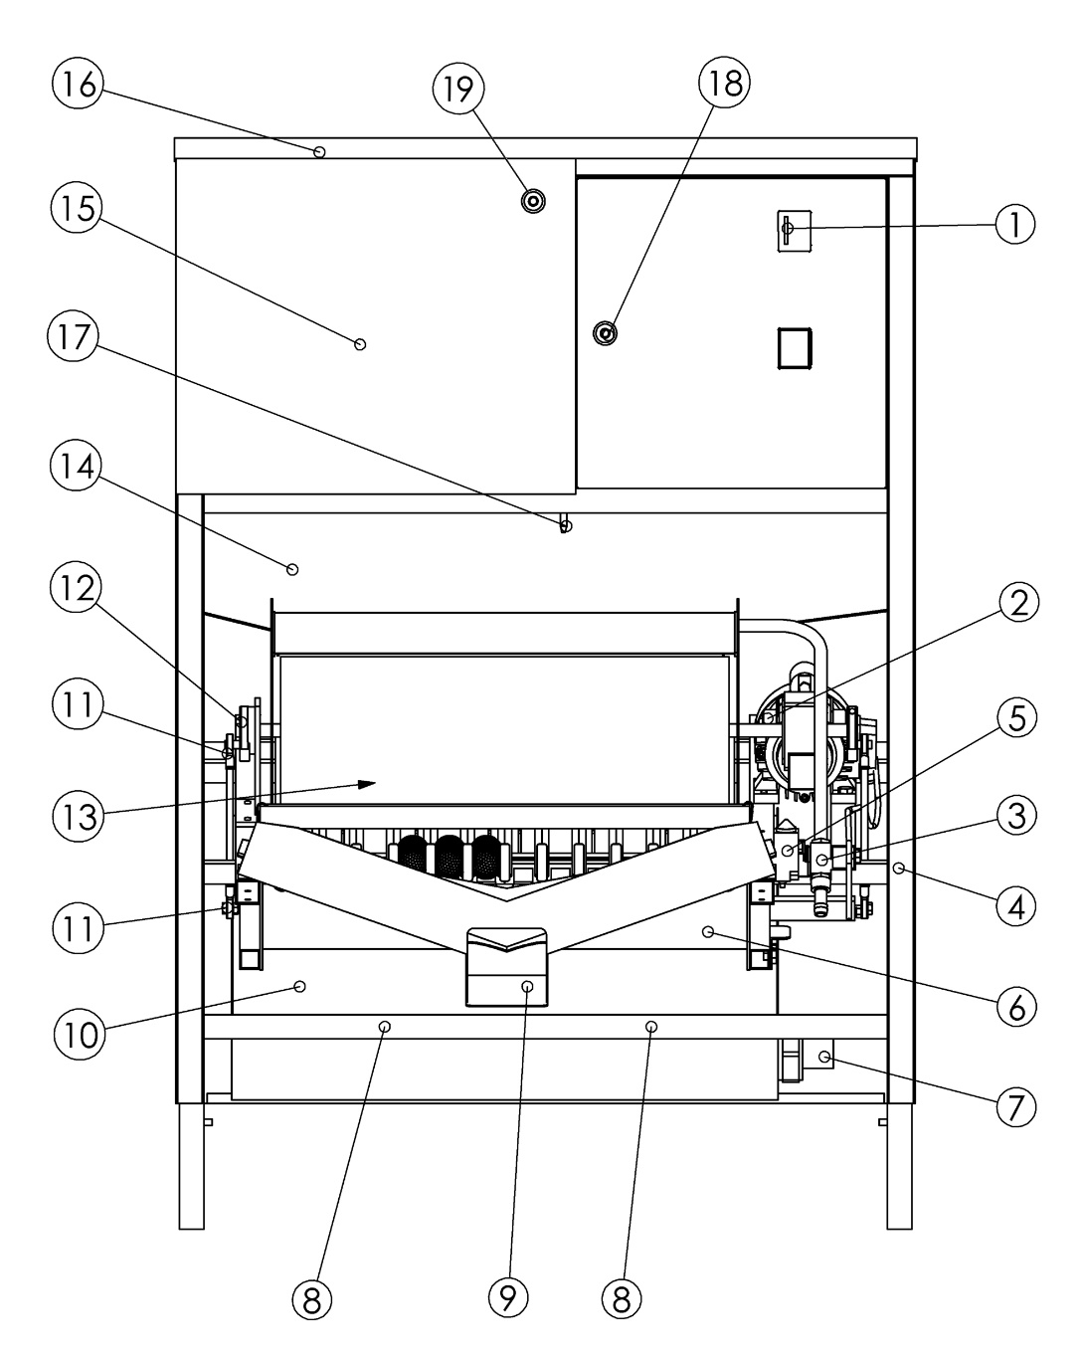
Image 4.1, survey

1. payment system(s) | 11. rod head bearings (4x)
2. motor | 12. axle eccentrics (2x)
3. water supply | 13. brush unit
4. fasteners mechanism (2x) | 14. bottom plate
5. stop switch | 15. ball storage space
6. lift mechanism | 16. lid
7. water drain 40 mm | 17. locking pin
8. fasteners slick tank (2x) | 18. lock cash box department
9. ball outlet | 19. lock top lid
10. slick tank

Installation
Install the machine following these instructions:

- Put the machine on a strong hard water-level floor; when the machine inclines, it will impede the well-functioning of the machine. The machine stands correct when the lid has on each side 2 mm. margin from the side-walls. Check if all the paws touch the ground.
- Open the door of the coin insert unit (1). Here you will find the key to the lid. (16).
- Open the lock (18) with the key and open the lid.
- Pull the locking pin (17) up and take of the front flap.
- Take the ball extension clasp and stick this from the inside through the hole. Fasten the clasp with the 4 bolts (M6x16) and nuts.

Fix the screws of the ball extension tight; the ball extension prevents that
the users can come into the machine.

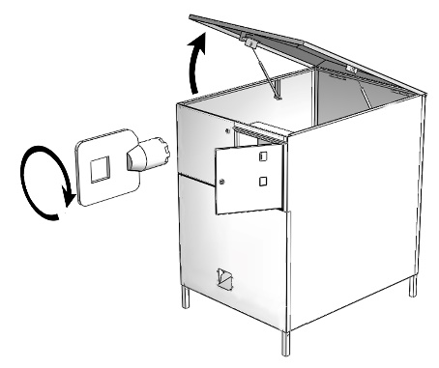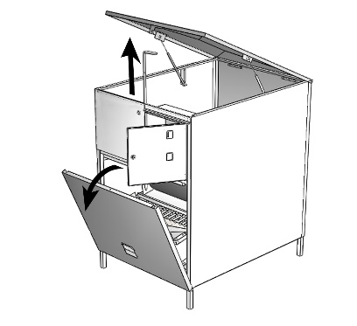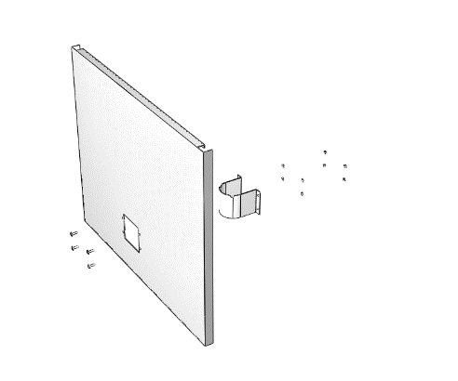
Image 5.1, installation

Connect the water-drainage (7) (40 mm) with the drain-pipe. For details see page 9. To install a new brush you can use the same steps. Grease the arbour against rust en pay attention that the new brush needs to be adjusted. Follow the directions in chapter 11.3.

- Connect the water delivery (3) with a ½” water hose to the water pipe. Block the water hose. Putt back the cover by putting it underneath again and then putt the locker at the upper side again in the hole. Stab the plug in point.

the machine may only be plugged in a socket with the correct voltage


Please pay attention that the power cord doesn’t lay around just like that.
WATCH OUT: never leave the chord lying in a puddle!

- Press the MAIN switch in the coin insert box ‘on’. The SIGNAL light will light up.
- Turn on the motor, with the button MOTOR. Then press RUN, in order to test the mechanism of the machine.
- Insert a coin in the coin insert unit, in order to test the operation of the machine.
- Fill the ball storage (15) and place a bucket under the ball delivery.
- If you insert a coin, the balls will be delivered. For delivery the ball dispenser is adjusted at 12 balls per cycle and 2 cycles per payment, unless otherwise specified on the order. Activate the dispensing several times until the whole grate is filled up until the front with balls.
- If you want to dispense a larger quantity of balls, you can change the adjustment. This can be done as follows: 1) by removing the pins from the grate, or 2) by choosing another connection to the control module.
- Each pin removed from the lintel behind the lift mechanism (6) the dispenser will give out 2 more balls per cycle. If you remove all the pins, the dispenser will give out 24 balls per cycle. The numbers mentioned on the control module are the same as the number of cycles: I1 = 1 cycle until I5 = 5 cycles.

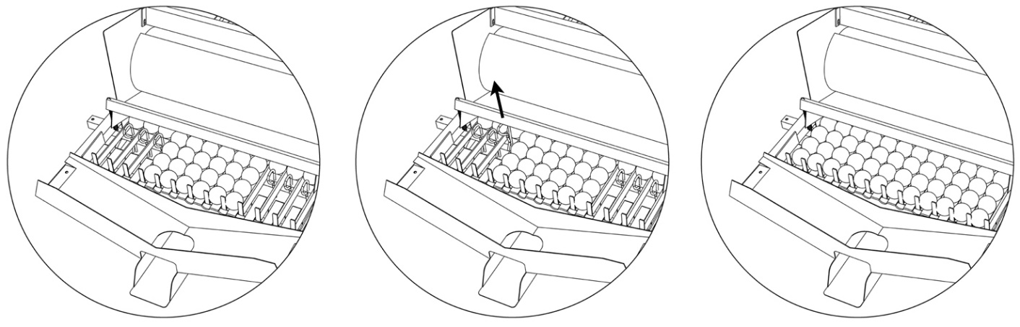
Image 5.3; removing the pins

- To let the mechanism turn more cycles, in order to dispense more balls per payment, please change connection of one of the wires. See chapter 9: wiring.
- Shut the peak, the lid and the door.
Pull the power plug from the socket before you open the dispenser.
Several parts of the machine maintain voltage when the plug is in the socket.

Shut off water supply when the machine is long term out of order.

Connections of water and electricity
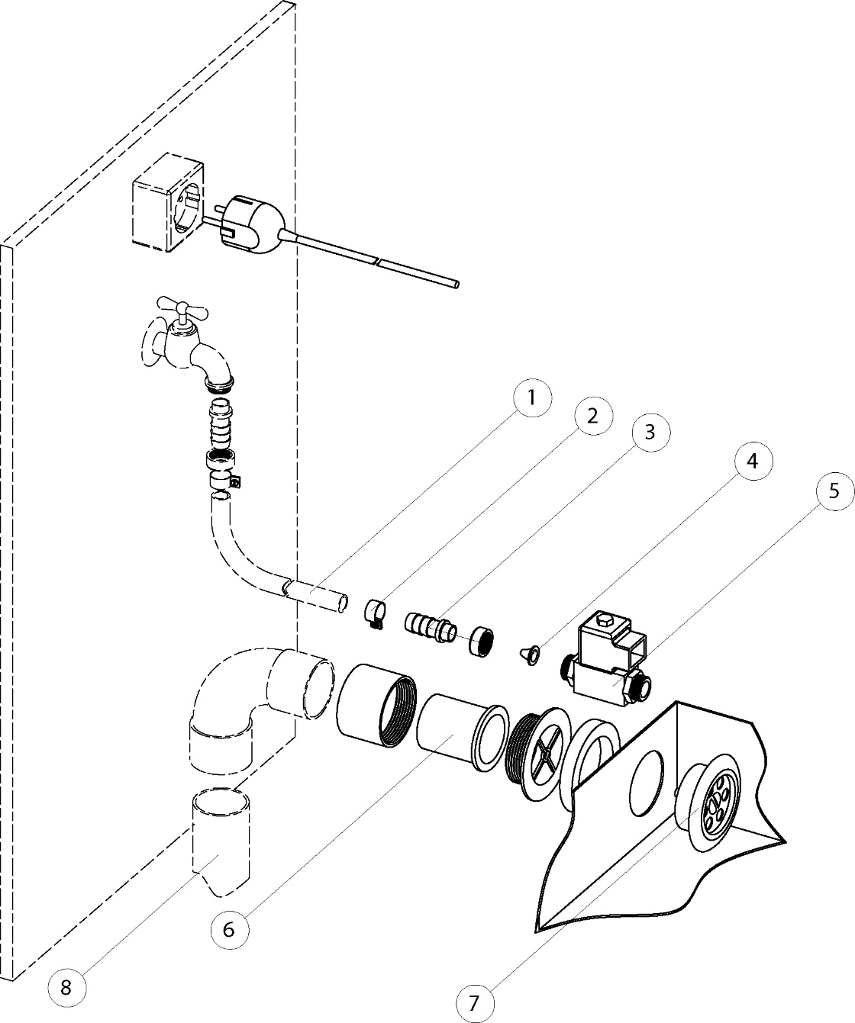
Image 5.1, connections

All connections are accessible via the front of the dispenser. The components with a striped line are not included parts of the dispenser.
1. water hose ½” | 5. water valve
2. hose connector | 6. pvc collar 40 mm ext.
3. hose connector | 7. rough water sieve
4. sieve | 8. pvc drain 40 mm ext. (not included)

Maintenance
Pull the power plug from the socket before cleaning the machine.
Several parts maintain under high voltage when the plug is in the socket.

Cleaning in general
The outside of the machine can be cleaned with a damp cloth and non-aggressive household liquid. Do not use aggressive liquids, the lack can be damaged. Heal the lack damage quickly, and then you will prevent further damage.

The electric parts like the motor (2), stop switch (5) and water flap (3) should not get in touch with water

Never use high pressure water to clean the machine.

Make sure that when filling the machine with balls no other things like leaves, branches and bricks come into the machine: check if there is no blockade.

Clean every time after filling the machine the slick tank (10) by removing the leaves, balls, sand and other dirt.

Remove dirt from the brushes.

Oiling

Grease the following parts at 01 February and 01 August with oil:
- The 4 bearings of the rod head bearings (11) by the axle eccentrics (12) at both sides of the lift mechanism (see image 6.1).
- The connection of the hydraulic springs to the lid.
- Hinges from the doors of the coin insert box.

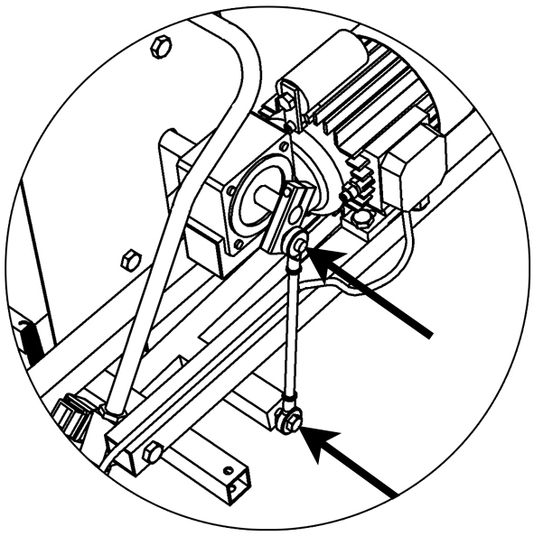
Image 6.1, oiling

Cleaning the coin mechanism
- Clean the mechanism regular with a wet cloth.
- If it is very dirty, you will have to take the mechanism out of the holder and clean it with liquid soap.
- After that, flush it of with warm water and dry it with a blow-dryer.
- Touch the return mechanism slightly with grease on the moving parts. Be provident with the grease and do not let it come into the coin channel.

ad.: also see 9.1

Grease in the coin channel will lead to impediment. Don’t use oil or an aerosol!

Draining water with frost
The machine has to be protected against frost. With frost all the water has
to be out of the pipe.

- Shut off the water delivery.
- Take the water hose off the machine side.
- Switch the motor "off" and the water at "on".
- Push the "RUN" button, so the water will go out of the machine.

Disorders
In case of disorder first consult the disorder table before contacting the service technician. With an easy construction most problems, not after going to a service technician, are easy to repair.

Pull the plug out of the socket before you open the dispenser.
Several parts of the machine maintain high voltage when the plug is in the socket.

In general

Ball dispensing
When there are problems with the ball dispense is this often because of dirt or strange things in the mechanism. These can be removed easily.

The brush has to stop in the right position, so that the balls can freely roll underneath it.

Insufficient water supply
In the connection swivel of the water delivery (3) is a sieve. Clean the sieve inside the swivel when there is too little flush water (when water supply is fully opened). Shut off the water delivery, unscrew the swivel and take it out of the machine. Don’t remove the sieve from the swivel, but remove only the dirt with a small brush.

Never spray water into the machine, also when the plug is not in the socket!

The sieve filters the dirt from the water, in order to protect the sensitive water valve.
If you remove the sieve, soon the water valve will not close anymore.

Trouble shouting guide
Always check first if the cables and plugs are connected and the switches stand in the right position!
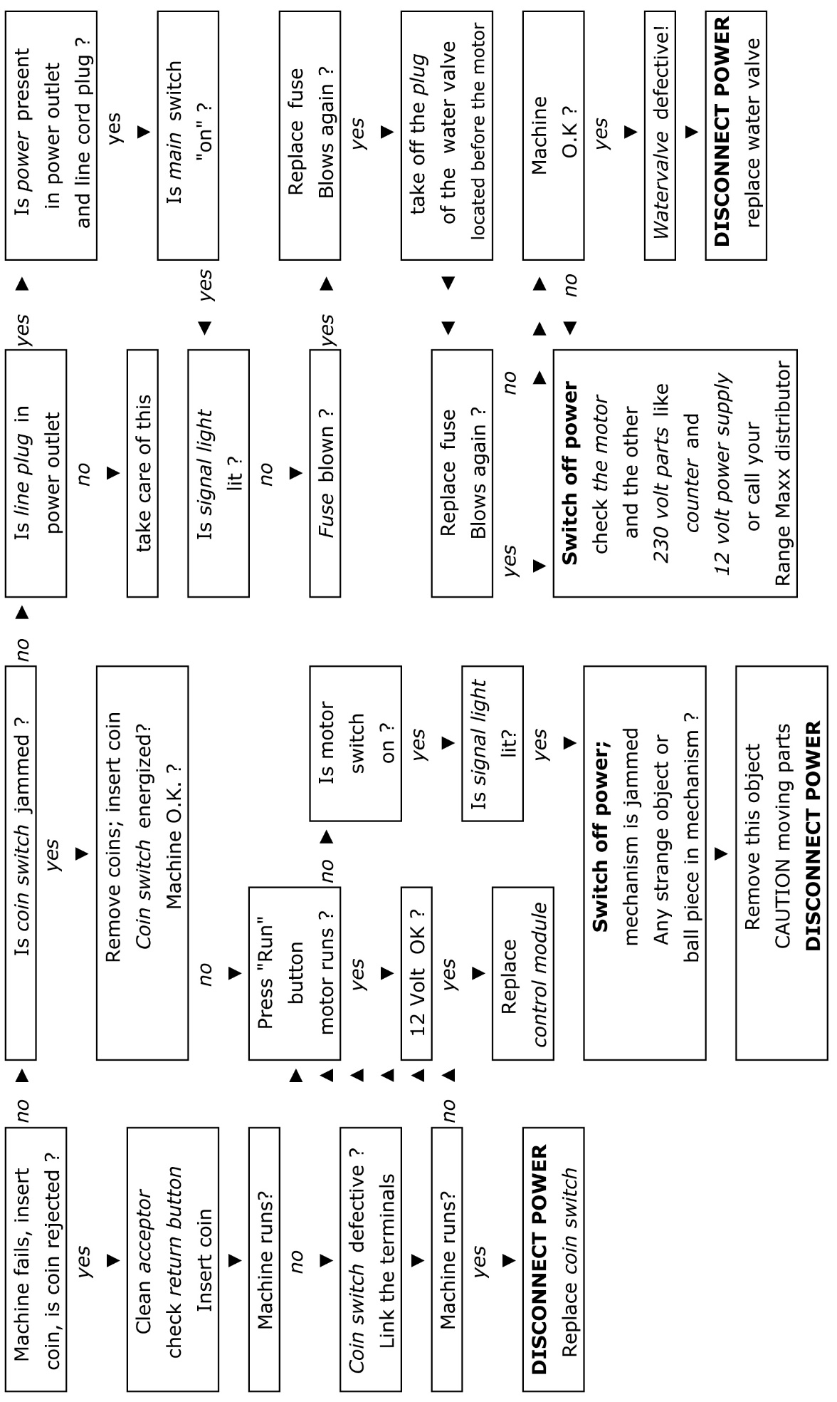

Wiring schedule
If you change the connection of the wire with number 1 from the coin insert unit to another entry in the control module (I1, I2, I3, I4, I5) the number of cycles can be changed from 1 up to 5. See schedule below.

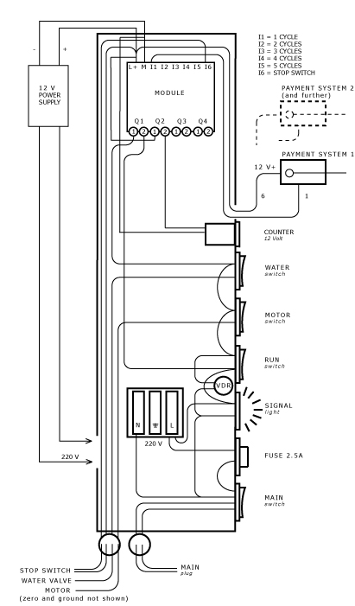

Image 8.1, wiring schedule (with optional second payment system)

To choose another connection and adjust the number of cycles, it is easy to disconnect the control module from the din rail. This can be done easy by putting a little screwdriver on top of the flap, and pushing the flap downwards until you hear a ‘click’. The module can now easily be cleared from the din rail.

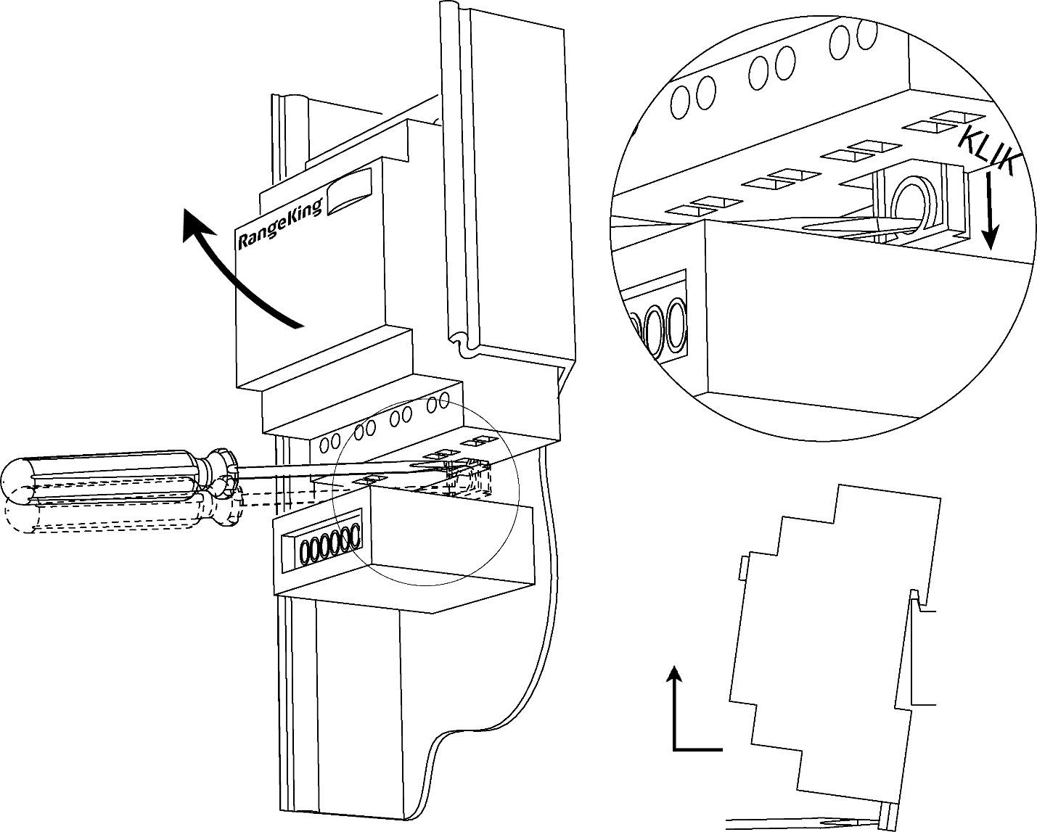
Image 8.2, removing control module

Payment systems
The Range Maxx® ball dispenser comes with a payment system for tokens, coins, magnetic cards, smart cards or any combination. The magnetic card system can not be serviced on the spot and therefore will not be described in this chapter. The systems where coins or tokens are used for payment will be described in chapter 9.1.

Sophisticated coin insert unit
Pull the plug out of the socket before you open the dispenser.
Several parts of the machine maintain high voltage when the plug is in the socket.

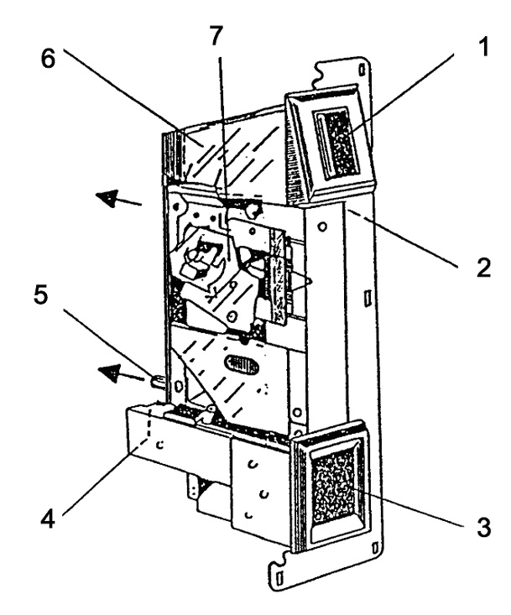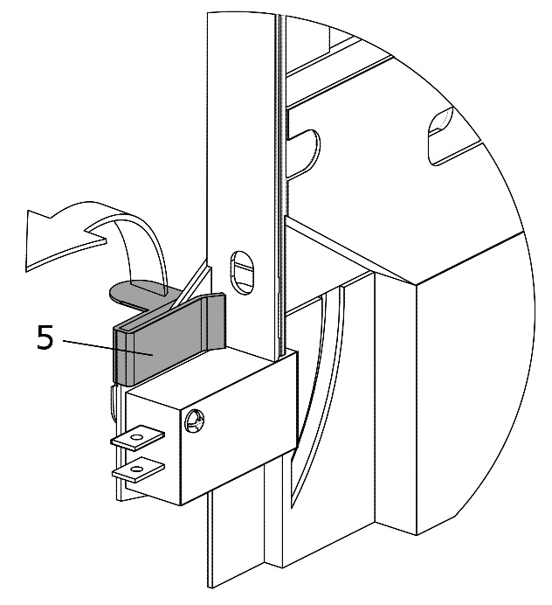
Image 9.1, coin-mechanism in the coin insert unit

1. reject button | 5. mounting clip
2. nylon return lever (place index) | 6. holder
3. coin return box | 7. coin mechanism, hinging top
4. coin switch (black, white or red button indicates toughness for different coins)

The coin insert unit not always has to be removed for maintenance or disorder. Mostly it is enough when you open the hinging part of the coin acceptor. Blocked coins can be removed from the mechanism.

The mechanism can be removed by opening the mounting clip (5).

Before mounting the coin acceptor, always place the white nylon return lever to
the top, otherwise the red return button will not work.

Technical specifications
Range Maxx® golf ball dispensers
 | Medium | Large | X-large | Twin medium | Twin large
Mains | 230 VAC 50 Hz | 230 VAC 50 Hz | 230 VAC 50 Hz | 230 VAC 50 Hz | 230 VAC 50 Hz
Power | 5/190 Watt | 5/190 Watt | 5/190 Watt | 2 x 5/190 Watt | 2 x 5/190 Watt
Empty weight | 236 kg | 245 kg | 280 kg | 490 kg | 515 kg
Filled weight | 640 kg | 785 kg | 1000 kg | 1390 kg | 1685 kg
Dimensions (cm) | 121 x 92 x 135 | 121 x 92 x 155 | 177 x 92 x 155 | 121 x 186 x 165 | 121 x 186 x 185
Storage capacity | 9.000 balls  (+ version: 1.000 extra) | 12.000 balls  (+ version: 1.000 extra) | 16.000 balls  (+ version: 1.000 extra) | 20.000 balls  (+ version: 2.000 extra) | 26.000 balls  (+ version: 2.000 extra)
Dispensing | 12-24 balls per cycle,  1 – 5 cycles | 12-24 balls per cycle,  1 - 5 cycles | 12-24 balls per cycle,  1 - 5 cycles | 12-24 balls per cycle,  1 - 5 cycles | 12-24 balls per cycle,  1 - 5 cycles

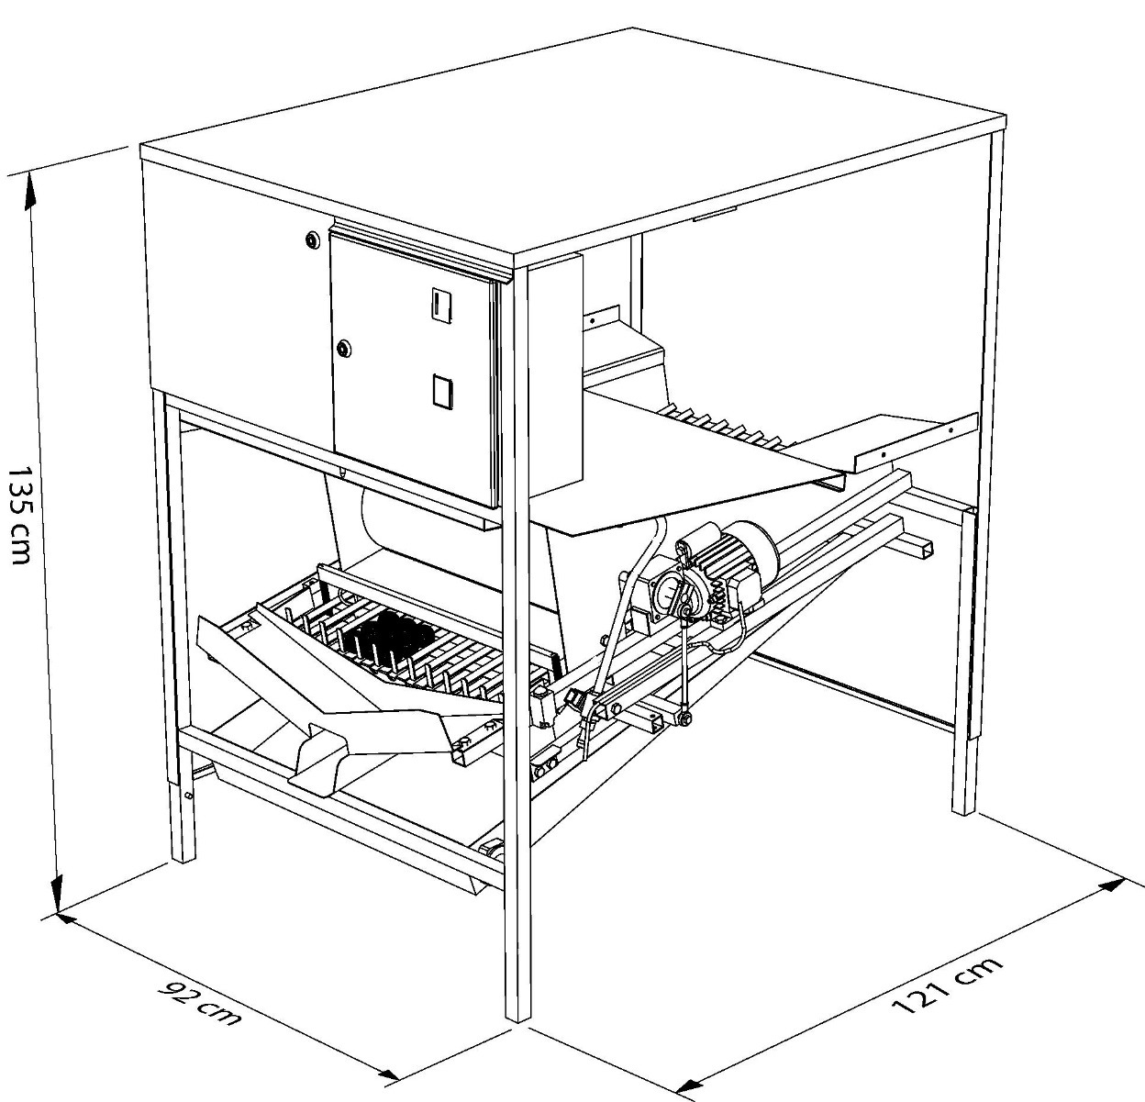

Image 10.1, Dispenser medium with dimensions (DxBxH)

Repair manual
Repairs and maintenance as described in this manual may exclusively be performed
by skilled and authorized personnel.

Always pull out the mains plug from the socket before performing maintenance.
Several parts of the machine maintain voltage as long as the plug is inside
the socket.

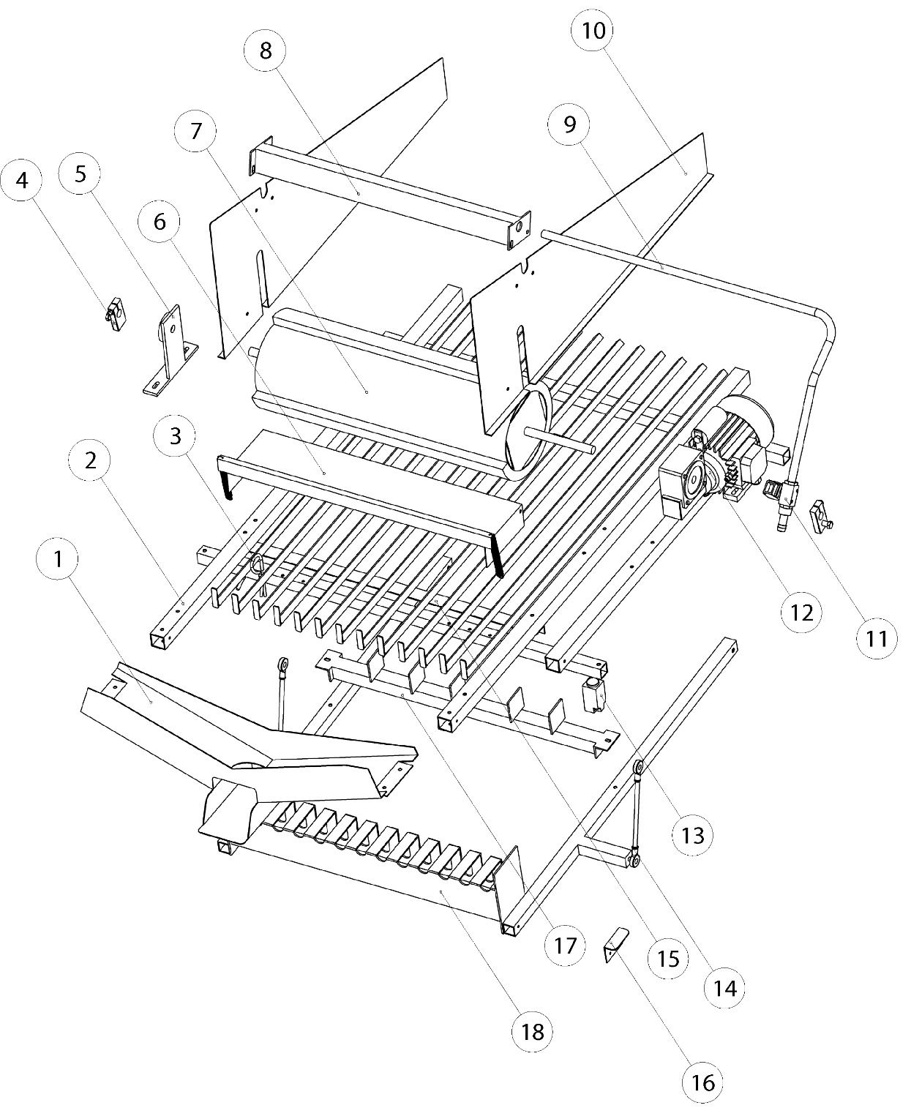
Image 11.1, exploded view

1. ball outlet | 11. water valve
2. base dispensing frame | 12. motor
3. blocking pin (6x) | 13. stop switch
4. axle eccentric (2x) | 14. rod head bearings (4x)
5. bearing support | 15. dripping strip
6. safety flap | 16. adjustment plate
7. brush role | 17. anti blocking bar
8. scratching bar | 18. lift mechanism
9. water pipe
10. side plate (2x)

  - Removing the dispensing mechanism
For mayor maintenance or reparations of the mechanism, it can be necessary to take the mechanism out of the cupboard. The mechanism can be taken out entirely through the front side. To do this safely, you need to follow the steps as described in the user’s manual.

Always pull out the mains plug before performing maintenance.
Several parts of the machine maintain power as long as the plug is inside
the socket.

- Check if the plug is out of the socket en shut off the water delivery.
- Disconnect the wires from the control module in the coin insert box.
- Dismantle the slick tank by reeling of the 2 bolts at the front.
- Let the slick tank slowly down, and take the behind loose from the hooks of the mechanism (dismantle the water discharge if necessary).
- The mechanism is at the front, left and right fastened to the cupboard: reel of the bolts.
- Pull the mechanism in your way. Meanwhile, capsize the mechanism to the right, so the supporting beams at the right hand side come underneath the support liners inside the cupboard. The mechanism must be supported underneath. The mechanism can now be taken out of the cupboard.

The mechanism weighs about 50 kg; it is smart to do the move with 2 persons.

Pull the electric plug out of the point before performing maintenance.
Several pieces from the machine conduct tension when the plug is put in.

[Aanslagplaatje] (16)
Bij onderhoud of kleine reparaties hoeft het mechanisme niet geheel uit
de kast gehaald te worden.

To place the mechanism back after repairing, the same steps can be followed in the opposite order.

  - Removing the brush
Should it be necessary to replace the brush of the Range Maxx® golf ball dispenser due to wearing out or otherwise, please follow the steps as described in this user’s manual.

Always pull out the mains plug from the socket before performing maintenance.
Several parts of the machine maintain voltage as long as the plug is inside
the socket.

- Take out the mechanism like described in chapter 11.1;
- Remove the clip blocks at both ends of the axle by releasing the bolts.

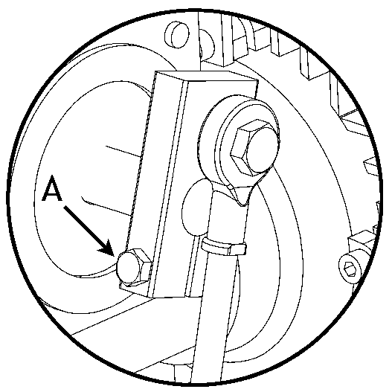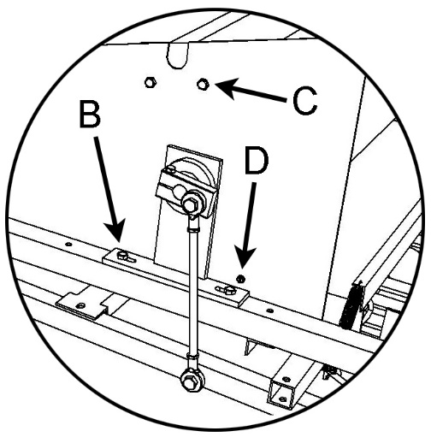
Image 11.2, dismantling the brush

- Take the bearing support (B) of the ball grating by reeling of the bolts.
- Turn on the side of the bearing support, the screws loose from the scratching bar (C) and the safety flap (D);
- Unscrew the left side plate and take it from the mechanism.
- The brush is now ‘free’ and can be taken out of the hollow spindle of the motor
- The brush has now been cleared and can be removed from the hollow axle of the motor.

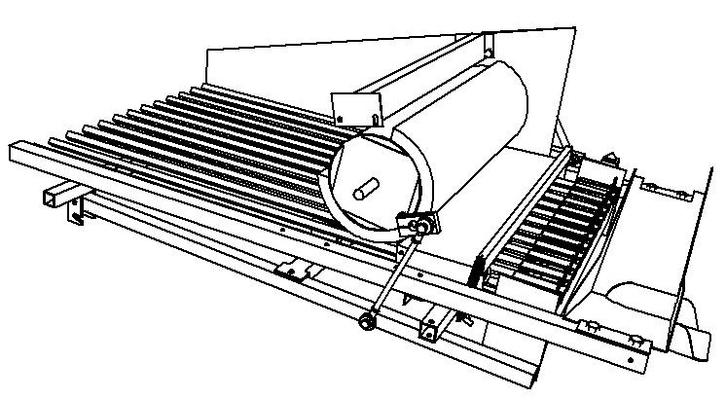
Image 11.3, cleared brush
To install the new brush you can follow the same steps. Lubricate the shaft to substitute rust and mind that the new brush has to be adjusted. Follow the successor instructions described in chapter 11.3.

  - Adjustment of the brush
Always pull out the mains plug from the socket before performing maintenance.
Several parts of the machine maintain voltage as long as the plug is inside
the socket.

The figure below illustrates the extension with the ball lift in the lowest position. In this position the first two lines with balls are above the lift and the interval of the brush is turned upside.

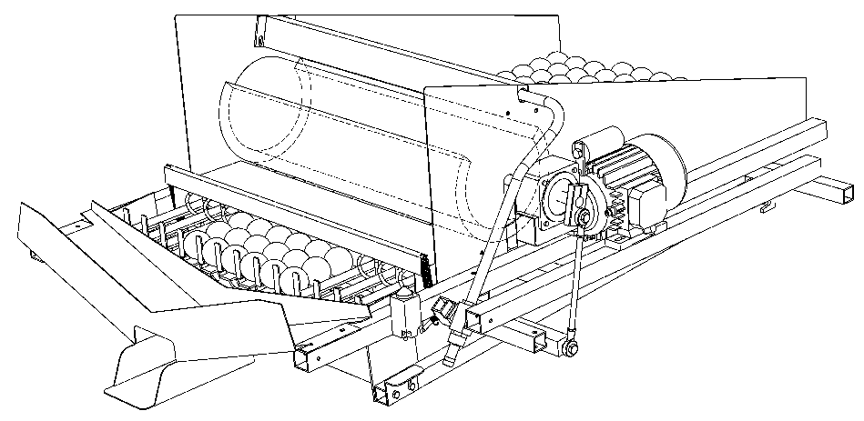
Image 11.4, mechanism in lowest position

In the second figure the mechanism is half a cycle further; in the stop-position. Before the mechanism is in this position, the lift has brought the first 2 lines with balls up and the brush has turned with it, so the interval is directed downwards at the stop moment the machine gives the balls.
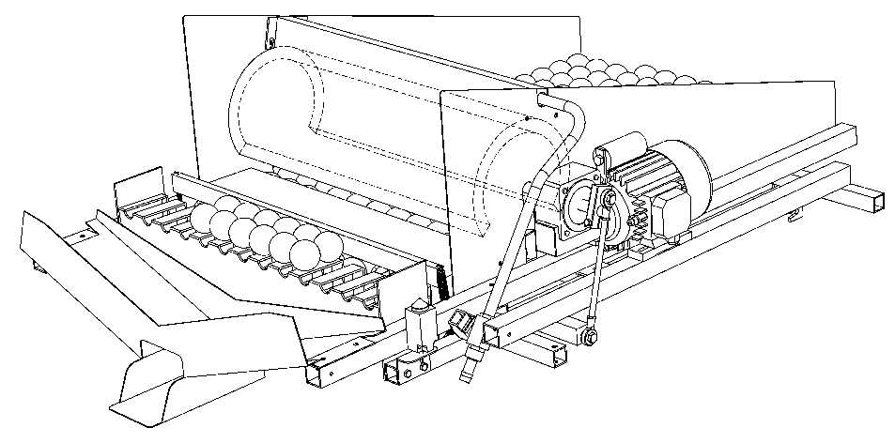
Image 11.5, mechanism during stop moment

When the brush-interval is not correctly adjusted by means of the balls at the grating, fewer balls will be dispensed. By following the next steps the mechanism will function optimal again.
WATCH OUT: As opposed to earlier warnings, you will now have to leave the pug in the socket. Watch out for rotating parts! Never stick your hands in a working machine!

Adjust the stop switch
- Put the lift mechanism by means of the RUN switch in its highest position (see figure 11.5; stop moment) adjust the adjustment plate so that the peg of the stop switch in this position can be pressed another 2 mm.
WATCH OUT: For no damage on the stop switch: leave several mm space
between the moment of switching and the end of the switch.

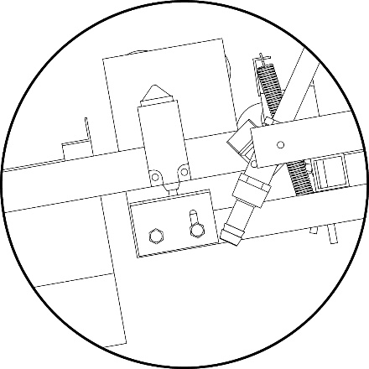
Adjustment plate (16)
Image 11.6, close-up stop moment

Insert a coin in the machine. The brush will turn and stop by means of the stop switch. The brush needs to be adjusted like in figure 11.7. For correction, loosen the axle eccentrics slightly (bolt A) and adjust at the axle.

Insert some more coins and check if the axle eccentrics both are in the same position according to the brush axle.
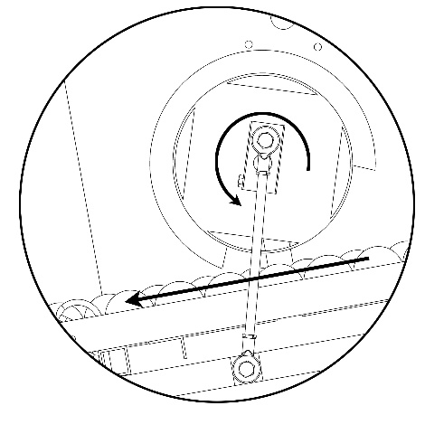
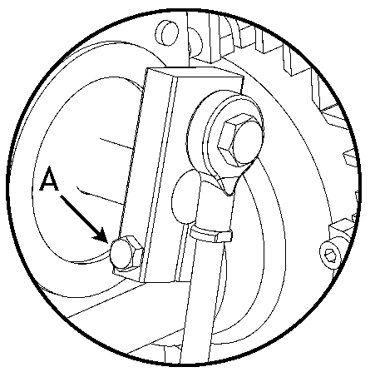

Image 11.7; adjust stop moment at axle eccentrics

Transport and replacement
To prevent damage to the stop switch you will have to put the machine in the lowest position before moving it. Change the position by using the RUN button.

  - Replacing card reader
Pull the plug from the socket when you are about to clean the machine.
Several parts maintain high voltage.

Disassembling the defective card reader from the coin insert box:
- Open the door of the coin insert box
- Disconnect the cables from the reader
- Unscrew the screws and loosen the synthetic brackets
- The reader can now be taking through the front door

Assembling the (new) card reader:
- Open the door of the coin insert box
- Slide the reader through the opening of the door
- Put the plastic bracket with the screws for the largest part in it at the flanks of the reader (see figure)
- Fix the screws until they touch the door
Beware: do not fix the screws too tight; fixed is fixed! By fixing the screws too tight,
the brackets can (and will) break.
- Connect the cable(s)
- Put the plug back in the socket, switch on the machine and test the card reader.

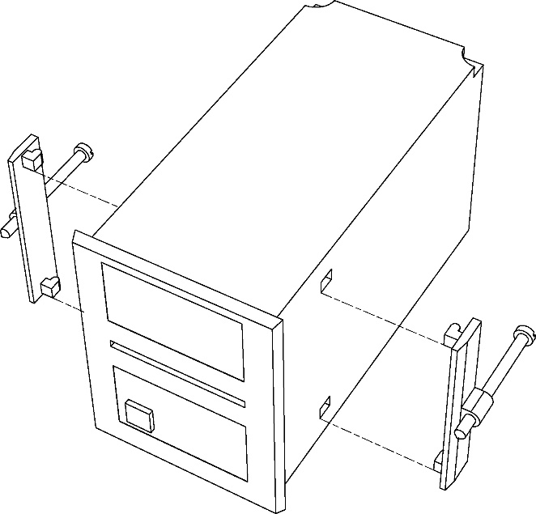
Image 11.4.1, card reader incl. connection

EU declaration of conformity
(directive 98/37/EG, addendum II, A)

Manufacturer: Range King® golf course equipment
Address: Dirk Storklaan 23-24
2132 PX Hoofddorp
Netherlands

Herewith declares that the:

Range Maxx® golf ball dispenser

Model: …………………………………………..
Production date: ……………………………………......

Serial nr.: ……………………………………......

to which this declaration applies, meets the requirements of the:
- machine directive 98/392/EEG
- EMC directive 89/336/EEG

And has been produced according to the following harmonised European standards:

- EN 292-1, EN 292-2, EN 292-2A

Date: ……………………………………......
Hoofddorp

Signature:

……………………………………......

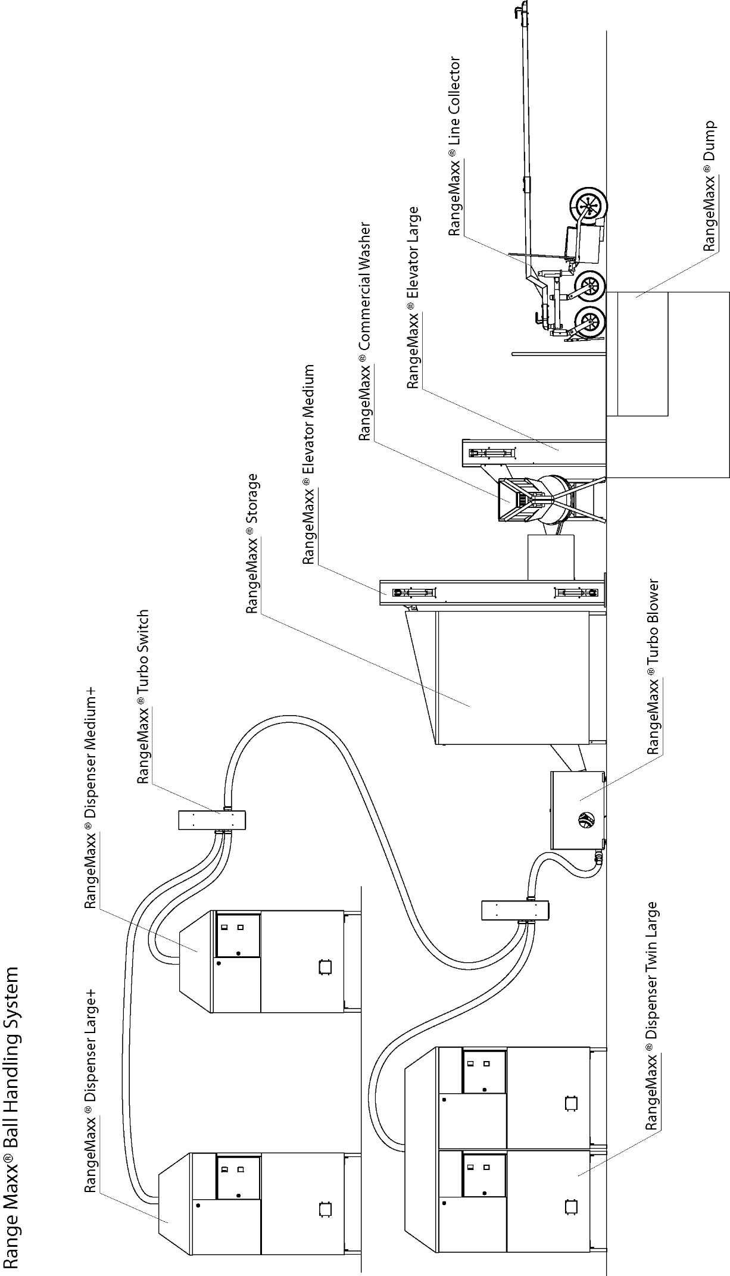
Dealer

